PulseLake: Cloud Data Lake for Real-Time IoT Analytics
Project report · Cloud Computing · Oct 11, 2026 · @Suyash Pathak

1. Abstract
PulseLake is a serverless cloud platform on Amazon Web Services (AWS) that collects live IoT data, detects and predicts device failures in real time, and stores every reading in a queryable data lake. Four smartphones act as IoT devices: they stream motion-sensor readings and user-controlled environment values over MQTT to AWS IoT Core once per second, and users can inject failures such as overheating, power surges, crashes and network loss.
In the cloud, an IoT Rules Engine filters messages and an AWS Lambda function raises alerts within about 1 second of a limit breach. A trend model predicted overheating 16 to 17 seconds before it happened, and silent device crashes were detected in about 3 seconds. Every reading is buffered through Amazon SQS into an Amazon S3 data lake with Bronze (raw JSON), Silver (cleaned Parquet) and Gold (Athena views) layers, catalogued in AWS Glue and queried with Amazon Athena.
The system also replays past sessions from the lake and scales from 4 phones to 200 virtual devices without configuration changes. It is defined entirely as code with AWS CloudFormation, costs about USD 0.05 per hour while streaming and almost nothing when idle, and is protected by AWS Budgets and an automatic kill switch. Total spend for development and testing stayed under USD 1 against a USD 25 cap.

2. Introduction
IoT systems need two kinds of insight from the same data stream: an answer within seconds when a device fails, and a full history that can be analysed later in ways nobody planned. Traditional systems meet these needs with separate servers, a live database and a warehouse, all sized for peak load and scaled by hand.
Cloud computing changes this model. Managed services such as message brokers, serverless functions and object storage scale automatically and are billed per use, so an idle system costs almost nothing. The data lake pattern adds a cheap, unlimited store that keeps raw data unchanged and lets analysts apply structure only at query time (schema-on-read).
PulseLake applies these ideas end to end. Smartphones are the IoT devices, because every student already owns one and its motion sensors produce real, noisy data. The project covers the full path a real IoT product needs:
- Secure device connectivity: MQTT over TLS with short-lived Cognito credentials and no secrets stored in the app.
- Real-time processing: an IoT Rules Engine and Lambda functions that detect failures, predict overheating and send alerts.
- A layered data lake: Bronze, Silver and Gold layers on Amazon S3, catalogued in AWS Glue and queried with Amazon Athena.
- Operations: a live dashboard, history replay, an elasticity test, Infrastructure as Code and strict cost controls.
The system runs in the AWS Sydney region (ap-southeast-2). The project account is restricted to that region and runs on the AWS Free plan, so the whole build was designed to stay within promotional credits.

3. Literature review
None of the 18 reviewed works combines secure device ingestion, cloud-side failure detection and prediction, a layered data lake and strict cost control in one low-cost, serverless system. That combination is the gap PulseLake addresses. Each title links to its DOI or arXiv record, and the Paper ID matches the numbered reference list in section 11.
Paper ID | Paper Title | Technique / Focus | Identified Research Gap
1 | Internet of Things (IoT): A vision, architectural elements, and future directions | Cloud-centric IoT vision and layered architecture | Conceptual architecture; no implemented end-to-end pipeline or evaluation of detection latency and storage cost.
2 | Fog computing and its role in the internet of things | Fog layer between devices and cloud for low latency | Requires deploying and maintaining fog nodes; long-term analytical storage of device data is not addressed.
3 | Edge Computing: Vision and Challenges | Processing at the network edge, offloading from the cloud | Vision paper; edge hardware adds management overhead and no unified real-time plus historical analytics is shown.
4 | Big IoT Data Analytics: Architecture, Opportunities, and Open Research Challenges | Architecture and challenges of big IoT data analytics | Survey and reference architecture only; no working serverless implementation or cost evaluation.
5 | A survey of mobile phone sensing | Smartphone sensors as a sensing platform | Predates managed IoT clouds; no cloud-side failure detection, alerting or data lake for phone data.
6 | MQTT-S: A publish/subscribe protocol for Wireless Sensor Networks | Lightweight publish/subscribe protocol for sensors | Protocol-level work; cloud processing, storage and analytics of the published data are out of scope.
7 | Stress-Testing MQTT Brokers: A Comparative Analysis of Performance Measurements | Performance of self-hosted MQTT brokers under load | Brokers run on fixed servers that users must size and operate; no downstream analytics pipeline.
8 | Building a replicated logging system with Apache Kafka | Replicated, high-throughput distributed log | Needs always-on broker clusters to run and pay for; heavy for small fleets with idle periods.
9 | Lambda architecture for cost-effective batch and speed big data processing | Separate batch and speed layers for big data | Two processing paths to build and maintain on cluster frameworks; idle capacity still costs money.
10 | Data Lake Management: Challenges and Opportunities | Metadata, discovery and integration in data lakes | General data lakes; real-time ingestion and alerting for IoT streams are not covered.
11 | A Zone Reference Model for Enterprise-Grade Data Lake Management | Zones (raw to curated) for organising a data lake | Conceptual zone model for enterprise data; no streaming IoT implementation or cost figures.
12 | Constance: An Intelligent Data Lake System | Metadata extraction and semantic querying in a lake | Batch-oriented metadata management; no continuous device ingestion or real-time alerts.
13 | Delta Lake: High-Performance ACID Table Storage over Cloud Object Stores | Transactional table layer over cloud object storage | Built around cluster compute engines; adds operational weight for a small, low-budget IoT workload.
14 | Serverless Computing: One Step Forward, Two Steps Back | Limits of Function-as-a-Service for data-centric work | Critiques general FaaS; does not evaluate short event-driven IoT functions with state in managed stores.
15 | Cloud Programming Simplified: A Berkeley View on Serverless Computing | Serverless model, benefits and open problems | General perspective; no IoT ingestion, detection or data-lake case study.
16 | Serverless Edge Computing: Vision and Challenges | Applying serverless functions at the edge | Vision paper; no implemented pipeline connecting devices to a cloud data lake.
17 | Predictive maintenance in the Industry 4.0: A systematic literature review | Review of predictive-maintenance methods | Literature review; no low-cost, real-time cloud implementation of failure prediction.
18 | Real-time big data processing for anomaly detection: A Survey | Techniques and frameworks for streaming anomaly detection | Survey of methods; no deployed end-to-end system with measured detection latency and running cost.

4. Problem statement
There is no simple, low-cost reference system that takes live data from real IoT devices, detects and predicts failures in the cloud within seconds, and keeps the complete history in an analysable data lake without running servers. The reviewed work leaves four concrete problems open:
- Fragmented pipelines: real-time processing (papers 2, 3, 9) and long-term data lakes (papers 10 to 13) are studied separately, so teams build two systems.
- Infrastructure overhead: brokers, stream clusters and lake engines (papers 7, 8, 9, 13) must be sized, operated and paid for even when devices are idle.
- Silent failures: a device that crashes or loses its network sends nothing, so systems that only react to incoming readings cannot notice it. Prediction before a failure is reviewed (paper 17) but rarely implemented cheaply.
- Unbounded cost: few designs enforce a hard spending limit, which matters for students, startups and pilots on fixed credit budgets.
PulseLake must therefore deliver real-time detection and prediction, a Bronze, Silver and Gold data lake, and elastic scaling on fully managed services. It must stay under a hard cap of USD 25 of cloud credits.

5. Project objectives and scope
The project aims to build and measure one working serverless pipeline from phone sensor to SQL report, with every objective verified by a test.

Objectives
No. | Objective | Measured result
O1 | Ingest live telemetry from 4 smartphones over MQTT with secure, secret-free authentication | Phone-to-dashboard delay about 0.3 s
O2 | Detect threshold failures in the cloud and alert on the dashboard and by email | Alert about 1 s after the 70 °C limit
O3 | Detect devices that fail silently (crash, network loss) | Crash flagged OFFLINE in about 3 s
O4 | Predict overheating before it happens | Warning 16 to 17 s in advance
O5 | Store all data in a Bronze, Silver and Gold data lake queried with SQL | ETL in 5 s; 328 KB JSON became 18 KB Parquet
O6 | Replay any past session from the lake | 10-minute window loaded in about 5 s
O7 | Show elasticity with a large virtual fleet through the same pipeline | 50 devices, 1,500 messages, 0 errors
O8 | Define all infrastructure as code and enforce a USD 25 spending cap | Kill switch tested; spend under USD 1

In scope
- Four smartphone slots (PHONE_01 to PHONE_04) as registered IoT Things, plus up to 200 virtual devices for load tests.
- Motion sensors read for real; temperature, humidity and voltage simulated with sliders, plus six injectable faults.
- One AWS region (Sydney, ap-southeast-2), a web dashboard, a phone web app and PowerShell deployment scripts.

Out of scope
- Dedicated sensor hardware (ESP32, Raspberry Pi), machine-learning models and user accounts with passwords.
- Multi-region deployment, mobile app-store apps and paid business-intelligence tools.

6. System diagram / Proposed architecture
Every phone message enters AWS IoT Core and then follows two serverless paths at once: a real-time path that raises alerts, and a data-lake path that keeps the full history for SQL analysis.
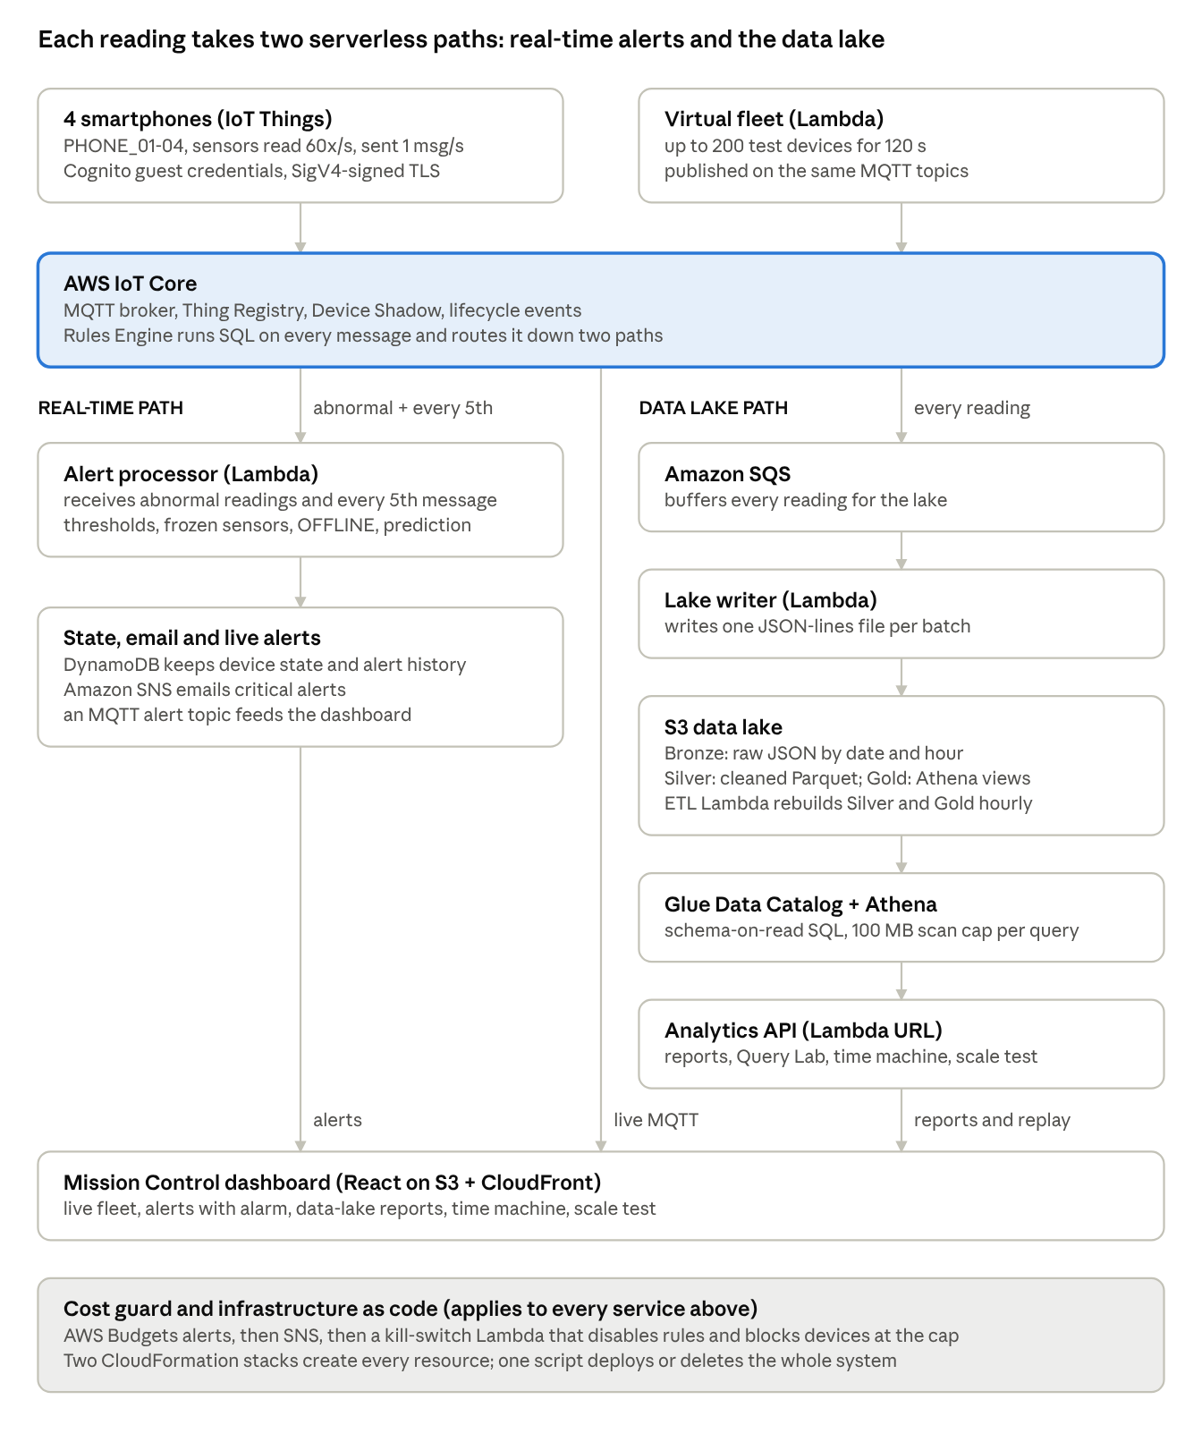
PulseLake architecture · two serverless paths from AWS IoT Core
The numbered steps below trace one reading through the system:
- A phone gets temporary credentials from Amazon Cognito and publishes one JSON message per second over MQTT with TLS.
- AWS IoT Core forwards the message live to the dashboard and runs it through five Rules Engine rules.
- Real-time path: abnormal readings, plus every 5th message, reach the alert-processor Lambda. It updates DynamoDB, predicts overheating, emails critical alerts through SNS and publishes alerts back over MQTT.
- Data-lake path: every reading goes through SQS to the lake-writer Lambda, which writes Bronze files to S3. The ETL Lambda turns them into Silver Parquet and Gold views.
- The analytics API queries the lake with Athena for reports, Query Lab, session replay and load-test results.
- Underneath, AWS Budgets and the kill-switch Lambda watch spending, and CloudFormation defines every resource.

7. Project module explanation
PulseLake is built from ten modules; each one is a separate, replaceable piece of code or infrastructure.

7.1 Device application (edge)
A React and TypeScript web page turns a phone into an IoT device, so any phone can join by scanning a QR code without installing an app. It reads the accelerometer and gyroscope about 60 times a second and sends a one-per-second summary (vibration RMS and peak, plus 10 orientation samples). This edge processing cuts the data sent by roughly 98%. Sliders simulate temperature and humidity, and six buttons inject faults: Overheat, Power Surge, Battery Critical, Sensor Freeze, Network Drop and Crash.

7.2 Secure connectivity
Each browser gets a guest identity from an Amazon Cognito identity pool, receives credentials valid for about an hour, and signs the AWS IoT WebSocket URL with Signature Version 4. The app stores no secrets. The guest role may only connect as PHONE_0x or a dashboard client and may only use the project's MQTT topics and the phones' device shadows.

7.3 Ingestion and routing (AWS IoT Core)
AWS IoT Core is the MQTT broker and Thing Registry. Its Rules Engine runs SQL on every message and routes it through five rules:
- bronze_telemetry: every reading goes to Amazon SQS for the data lake.
- telemetry_alerts: abnormal readings, plus every 5th message as a heartbeat sample, go to the alert Lambda. This filtering cuts Lambda calls by about 80%.
- presence: AWS connect and disconnect events go to the alert Lambda.
- device_events: joins, leaves and injected faults go to the alert Lambda and to S3.
- alert_archive: every alert is stored in S3.

7.4 Real-time failure detection
An AWS Lambda function (Python 3.12) decides what counts as a failure, so the phone only reports readings. It raises OVERHEAT above 70 °C, POWER_SURGE above 6 V, BATTERY_LOW below 10%, VIBRATION above a 15 m/s² peak, SENSOR_FROZEN after three identical readings, and OFFLINE for any disconnect without a GOODBYE message. Device state lives in Amazon DynamoDB, and conditional writes make each alert fire once and resolve itself. Critical alerts are emailed through Amazon SNS.

7.5 Failure prediction
For each device the Lambda keeps the last 25 seconds of temperatures and fits a least-squares trend line. If temperature rises faster than 0.15 °C per second and the line will cross 70 °C within 60 seconds, it raises PREDICTED_OVERHEAT. When the real overheat follows, the alert records the lead time, which measured 16 to 17 seconds.

7.6 Data lake and ETL
The data lake uses three layers on Amazon S3:
- Bronze: raw JSON, unchanged, partitioned by date and hour. A lake-writer Lambda reads SQS in batches and writes one file per batch, avoiding thousands of tiny files.
- Silver: an Amazon Athena CTAS job converts Bronze to compressed Parquet. It removes duplicates, rejects impossible readings and types the columns.
- Gold: Athena views for hourly device statistics, fleet health and alert summaries.
The AWS Glue Data Catalog describes every table with partition projection, so no paid crawler is needed. The ETL runs from a dashboard button or hourly via Amazon EventBridge Scheduler, and skips itself when no new data has arrived.

7.7 Analytics API and Query Lab
A Lambda function behind a public function URL serves device state, recent alerts, data-lake statistics and seven preset Athena reports. A read-only Query Lab accepts a single SELECT statement. Every query is capped at 100 MB scanned, and each report costs about USD 0.00005.

7.8 Time machine
The analytics API finds past phone sessions in the Bronze layer and returns any window of up to 15 minutes. The dashboard replays it through the same live view at 1x to 8x speed, including joins, injected faults and alerts. This shows the main value of a data lake: raw history can be re-read at any time.

7.9 Scalability test
A fleet-simulator Lambda publishes telemetry for up to 200 virtual devices once per second for up to 120 seconds, through the same pipeline. About 6% of virtual devices develop faults, so detection is exercised at scale. Runs are limited to 10 per day, and virtual devices never send email.

7.10 Dashboard, infrastructure as code and cost governance
The PC dashboard has three tabs: Live fleet, Data lake and Scale test. It shows an animated data-flow diagram, a 3D phone per device that copies the real phone's tilt, live charts, alerts with an alarm, and a credits meter. Two AWS CloudFormation stacks create every resource, and one script deploys or deletes the whole system. Cost is protected in five layers:
- The AWS Free plan, which cannot charge a card.
- AWS Budgets alerts at USD 5, 8, 9, 18 and 22.
- A kill-switch Lambda that disables all rules, blocks device connections and freezes the simulator when a cap is crossed.
- Usage limits: phone auto-sleep, query scan caps and load-test limits.
- A teardown script that deletes everything after evaluation.

8. System requirements
The system needs only ordinary phones, one PC and an AWS account; there are no servers to buy or rent.

8.1 Hardware
Item | Requirement | Used in this project
IoT devices | Smartphones with a modern browser and motion sensors | 4 phones (Android and iPhone)
Dashboard and development PC | 64-bit laptop or desktop, 8 GB RAM, internet access | Windows 11 PC
Network | Wi-Fi or mobile hotspot that allows secure WebSockets (port 443) | Mobile hotspot for the demo

8.2 Software
Item | Version / detail
Operating system (PC) | Windows 11 (any OS that runs the tools below)
Browser | Chrome, Edge or Safari, with HTTPS; motion permission on iPhone
AWS CLI | Version 2, signed in with aws login
Node.js and npm | Node 24, npm 11 (build the web app)
Python | 3.12 (Lambda runtime and local checks)
Front-end libraries | React 18, TypeScript 5, Vite 5, mqtt.js 5, qrcode
Infrastructure tools | AWS CloudFormation, cfn-lint, PowerShell scripts, Git

8.3 Cloud services (AWS, region ap-southeast-2)
AWS IoT Core (broker, Thing Registry, Rules Engine, Device Shadow), Amazon Cognito, AWS Lambda (6 functions), Amazon SQS, Amazon S3, AWS Glue Data Catalog, Amazon Athena, Amazon DynamoDB, Amazon SNS, Amazon EventBridge Scheduler, Amazon CloudFront, AWS CloudFormation, AWS Budgets, AWS Systems Manager Parameter Store, Amazon CloudWatch Logs and AWS IAM.

8.4 Functional requirements
- A phone joins as one of four device slots and streams telemetry once per second; the dashboard shows it live.
- The cloud raises, de-duplicates and resolves alerts for threshold breaches, frozen sensors and unexpected disconnects.
- The cloud warns before an overheat when the temperature trend will cross the limit within 60 seconds.
- Critical alerts reach the dashboard with sound and arrive by email.
- Every reading, event and alert is stored in the Bronze layer; an ETL builds the Silver and Gold layers.
- Users run preset SQL reports and read-only queries, and replay any past session.
- The dashboard can change a phone's data rate, reset a fault and make it flash (Locate) through the device shadow.
- A load test launches up to 200 virtual devices through the same pipeline.

8.5 Non-functional requirements
Quality | Target
Latency | Phone to dashboard under 1 s; failure alert within a few seconds
Scalability | 4 to 200 devices with no configuration change
Cost | About USD 0.05 per hour while streaming, about USD 0 when idle, hard cap USD 25
Security | TLS everywhere, temporary credentials, least-privilege IAM, private buckets
Reliability | Alerts fire once per incident; out-of-order and repeated messages are ignored
Maintainability | Whole system created or deleted from code with one command

9. Conclusion
PulseLake shows that one person can build a complete real-time IoT analytics platform from managed cloud services alone, with no servers, for well under USD 1. Real smartphones streamed sensor data through AWS IoT Core. The cloud flagged failures within about a second, caught silent crashes in about 3 seconds and predicted overheating 16 to 17 seconds ahead.
The Bronze, Silver and Gold data lake kept every reading, shrank raw JSON about 18 times as Parquet, answered SQL reports in 1 to 2 seconds and replayed past sessions on demand. The same pipeline handled a jump from 4 phones to a virtual fleet without any configuration change. CloudFormation, AWS Budgets and a tested kill switch kept the system reproducible and inside its spending cap.
Together, these results close the gaps found in the literature: real-time detection and long-term analytics now live in one serverless design, silent failures are caught, and cost is bounded by design rather than by hope.

10. Future scope
The design can grow in six directions without changing its core pipeline:
- Real sensor hardware: ESP32 or Raspberry Pi boards with physical temperature, humidity and current sensors, publishing to the same MQTT topics.
- Stronger device identity: X.509 certificates per device and authenticated user accounts instead of guest identities.
- Learned anomaly detection: models trained on the Silver layer to catch failure patterns that fixed thresholds and a linear trend miss.
- Richer predictions: battery-drain and vibration-wear forecasts, not only overheating.
- Multi-region resilience: replicating the data lake and failing over the broker to a second AWS region.
- Fleet-scale operations: AWS IoT fleet indexing, over-the-air updates and dashboards for thousands of devices.

11. References
References 1 to 18 match the Paper IDs in the literature review; their details were checked against Crossref, Semantic Scholar and arXiv records. References 19 to 21 are AWS documentation used during implementation.
- J. Gubbi, R. Buyya, S. Marusic, and M. Palaniswami, "Internet of Things (IoT): A vision, architectural elements, and future directions," Future Generation Computer Systems, 2013. doi:10.1016/j.future.2013.01.010
- F. Bonomi, R. Milito, J. Zhu, and S. Addepalli, "Fog computing and its role in the internet of things," in Proc. 1st Edition of the MCC Workshop on Mobile Cloud Computing, 2012. doi:10.1145/2342509.2342513
- W. Shi, J. Cao, Q. Zhang, Y. Li, and L. Xu, "Edge computing: Vision and challenges," IEEE Internet of Things Journal, 2016. doi:10.1109/JIOT.2016.2579198
- M. Marjani, F. Nasaruddin, A. Gani, A. Karim, I. A. T. Hashem, A. Siddiqa, and I. Yaqoob, "Big IoT data analytics: Architecture, opportunities, and open research challenges," IEEE Access, 2017. doi:10.1109/ACCESS.2017.2689040
- N. Lane, E. Miluzzo, H. Lu, D. Peebles, T. Choudhury, and A. Campbell, "A survey of mobile phone sensing," IEEE Communications Magazine, 2010. doi:10.1109/MCOM.2010.5560598
- U. Hunkeler, H. L. Truong, and A. Stanford-Clark, "MQTT-S: A publish/subscribe protocol for wireless sensor networks," in Proc. 3rd Int. Conf. Communication Systems Software and Middleware (COMSWARE), 2008. doi:10.1109/COMSWA.2008.4554519
- B. Mishra, B. Mishra, and A. Kertesz, "Stress-testing MQTT brokers: A comparative analysis of performance measurements," Energies, 2021. doi:10.3390/en14185817
- G. Wang, J. Koshy, S. Subramanian, K. Paramasivam, M. Zadeh, N. Narkhede, J. Rao, J. Kreps, and J. Stein, "Building a replicated logging system with Apache Kafka," Proc. VLDB Endowment, 2015. doi:10.14778/2824032.2824063
- M. Kiran, P. Murphy, I. Monga, J. Dugan, and S. S. Baveja, "Lambda architecture for cost-effective batch and speed big data processing," in Proc. IEEE Int. Conf. Big Data, 2015. doi:10.1109/BigData.2015.7364082
- F. Nargesian, E. Zhu, R. J. Miller, K. Q. Pu, and P. C. Arocena, "Data lake management: Challenges and opportunities," Proc. VLDB Endowment, 2019. doi:10.14778/3352063.3352116
- C. Giebler, C. Gröger, E. Hoos, H. Schwarz, and B. Mitschang, "A zone reference model for enterprise-grade data lake management," in Proc. IEEE 24th Int. Enterprise Distributed Object Computing Conf. (EDOC), 2020. doi:10.1109/EDOC49727.2020.00017
- R. Hai, S. Geisler, and C. Quix, "Constance: An intelligent data lake system," in Proc. 2016 Int. Conf. Management of Data (SIGMOD), 2016. doi:10.1145/2882903.2899389
- M. Armbrust et al., "Delta Lake: High-performance ACID table storage over cloud object stores," Proc. VLDB Endowment, 2020. doi:10.14778/3415478.3415560
- J. M. Hellerstein, J. Faleiro, J. E. Gonzalez, J. Schleier-Smith, V. Sreekanti, A. Tumanov, and C. Wu, "Serverless computing: One step forward, two steps back," arXiv:1812.03651, 2018. arXiv
- E. Jonas et al., "Cloud programming simplified: A Berkeley view on serverless computing," arXiv:1902.03383, 2019. arXiv
- M. S. Aslanpour et al., "Serverless edge computing: Vision and challenges," in Proc. Australasian Computer Science Week Multiconference (ACSW), 2021. doi:10.1145/3437378.3444367
- T. Zonta, C. A. da Costa, R. da Rosa Righi, M. J. de Lima, E. S. da Trindade, and G. P. Li, "Predictive maintenance in the Industry 4.0: A systematic literature review," Computers & Industrial Engineering, 2020. doi:10.1016/j.cie.2020.106889
- R. A. Ariyaluran Habeeb, F. Nasaruddin, A. Gani, I. A. T. Hashem, E. Ahmed, and M. Imran, "Real-time big data processing for anomaly detection: A survey," International Journal of Information Management, 2019. doi:10.1016/j.ijinfomgt.2018.08.006
- Amazon Web Services, "Control access to Lambda function URLs," AWS Lambda Developer Guide. docs.aws.amazon.com
- Amazon Web Services, "Functions," AWS IoT Core Developer Guide (IoT SQL reference). docs.aws.amazon.com
- Amazon Web Services, "Sign in through the AWS Command Line Interface," AWS Sign-In User Guide. docs.aws.amazon.com

